Hi Valerie,

Considering some of the challenges associated with doing trait-based work (Lysimeter status at Hopland REC, cancellation of potential funding sources), I think it may make the most sense to reconsider my chapter structure and the potential use of existing data to generate a separate paper that addresses similar concepts to what I’m exploring in my scaling work without being focused on the same interaction with nutrient addition.

After attending a scaling analysis workshop at ESA and talking to some of the workshop folks (Dan McGlinn, Jon Chase, Nick Gotelli, etc.), I think there’s a good case to turn 2016 spring fieldwork into a separate analysis.

As I discovered from my literature reviews and discussion with the above researchers, there is a very limited knowledge base on how the choice of sampling grain affects the interpretation of scaling biodiversity and spatial structure. I’ve done a little bit of my own analysis on this question, which informed my choice of sampling scale, but I think this could be expanded by incorporating a couple new elements.

**Theoretical overview:**

* The exploration of species diversity patterns is a critical tool to understanding the effects of ecological processes
  + Concepts of alpha, beta, and gamma diversity, in particular, are used to compare community structure, and detect changes driven by different processes
* While many textbooks on experimental design devote a lot of space to the discussion of sampling design, these are most often related to tradeoffs between measurement variation and sampling effort. And even with this attention, standardized sampling grains have become common in many experimental protocols (i.e. the 1m2 sampling quadrat).
* We are paying increasing attention to the role that sampling methodology plays in evaluating diversity structure. For example, conclusions drawn from observed community change in response to species invasion and nutrient enrichment, or even the presence of neutral patterns of assembly may be strongly dependent on the grain and extent of sampling.
* Despite this increasing interest in scale-dependence, there are few quantitative evaluations of how variation in sampling scale affects interpretation of diversity structure and the shape of species accumulation curve.
* All communities exhibit spatial structure, to some extent—though we are generally aware of this fact, we often fail to incorporate spatial patterns in our evaluation of community diversity, particularly in very local contexts. Changes in sampling area are likely to pick up the influence of processes operating at different scales.
* Provided that sampling grain and extent is small enough to pick up spatial structure, different sampling grains are likely to have different relationships between area sampled and rate of diversity accumulation.
* Furthermore, different sampling scales are likely to exhibit varying sensitivities to rare taxa—smaller, more dispersed sampling units can be expected to quickly capture the relative abundance of common species, but miss out on rare taxa.
* Tie into 2 components of diversity structure:
  + Rate of accumulation of species diversity
  + Interpretation of the spatial structure of communities
* 2016 sampling data, containing estimates of community diversity across a series of nested subplots (in which larger plots necessarily contain all of the species in smaller plots) might be an interested dataset to use to explore these concepts.
* What I wasn’t aware of when first analyzing this data, was the presence of some recently developed analysis tools that overcome limitations of classic biodiversity indices. Comparison of species richness between plots and subplots, for example, is interesting but standard and known to be problematic in interpretation if presented alone. Abundance-weighted diversity metrics are better, and as of a few years ago, possible to be compared across scales (*see section at end of document*).

I suggest asking the following questions:

1. How does variation in sampling scale affect the rate of accumulation of species diversity?

***Hypothesis:*** Smaller sampling grain should accumulate species diversity more rapidly than larger sampling grains for a given spatial extent, as a function of total area sampled. Accumulation of smaller samples are expected to quickly reach diversity saturation when the abundance of common species is emphasized—smaller scales will be more likely to fail to encounter rare species.

1. How does variation in sampling scale affect interpretation of spatial structure across plant communities?

***Hypothesis:*** Smaller sampling scales will be more sensitive to fine-scale variation in community spatial structure. Larger sampling scales will pick up significant spatial heterogeneity at greater distances.

1. Worth thinking about some species abundance distribution analysis? To further confirm the assumption that rare species are less represented in the smaller sampling scale dataset, could compare deviance from larger scale dataset as a function of rank abundance.

Example graph below:

**Sampling grain**

**Rank abundance**

**100**

**1**

**0%**

**1 x 1**

**Deviation in relative abundance**

**.5 x .5**

**100%**

**(absent)**

**.25 x .25**

**Background to Linearized Abundance Metrics**

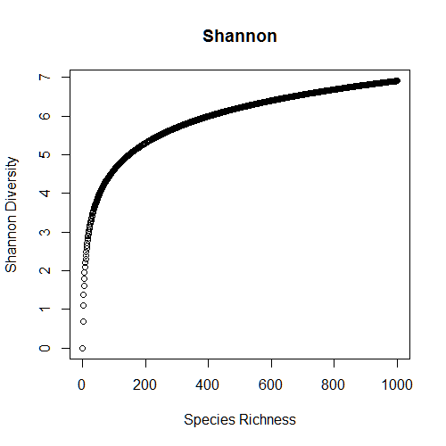A key part to understanding any proposed changes in analysis is the linear transformation of abundance-weighted diversity metrics, discussed in Jost (2006) and Jost et al. (2007). In brief, Jost notes that current abundance weighted-diversity metrics, like Shannon-Weiner or Simpson Diversity, produce nonlinear estimates of species diversity that depend on the total number of species.

Consider the graph to the right – here, we show Shannon diversity values on the Y-axis and the species richness of a simulated community containing X number of evenly abundant species. Counter-intuitively, the difference in Shannon diversity between communities containing 100 species and 200 species is greater than the difference in diversity between a community containing 200 species and another with 800. In general, this problem isn’t a problem, because we rarely compare communities with huge differences in the number of species. However, it is an issue with **scaling data**, where a community at the smallest spatial scale might only represent 1/50th of the species at the largest spatial scale.

To address this issue, Jost (2006) presents a linearized version of these diversity metrics:



It works similarly to other abundance-weighted diversity metrics (diversity is equal to the sum of the relative proportion of all species ^ q), with a twist—the “q” in the formula denotes the diversity order, which can vary between 0-2. At q=0, diversity is equivalent to species richness (the influence of low-abundance species is maximized). At q=2, diversity is most dependent on high abundance species. At q=1, the impact of species richness on diversity is proportional to abundance.

When generating species accumulation curves, varying this diversity order value “q” can be used to show what drives changes in diversity value. Jost recommends calculating diversity using these 3 values (or a continuum between them) to show what types of species different sampling scales are picking up.